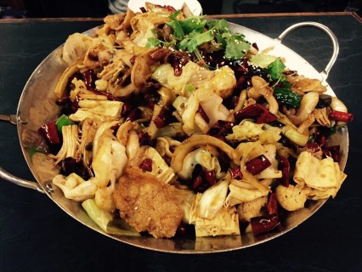

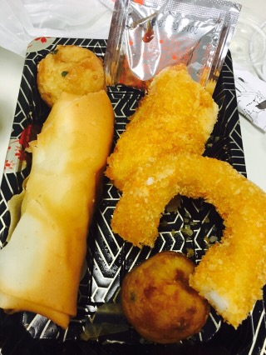

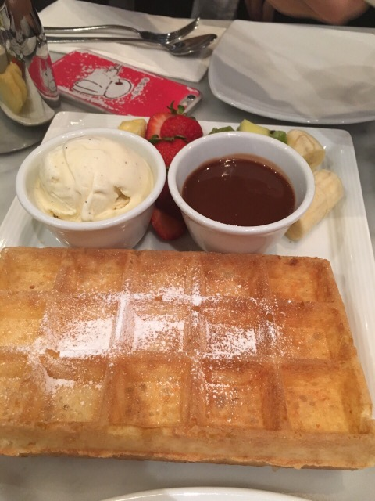

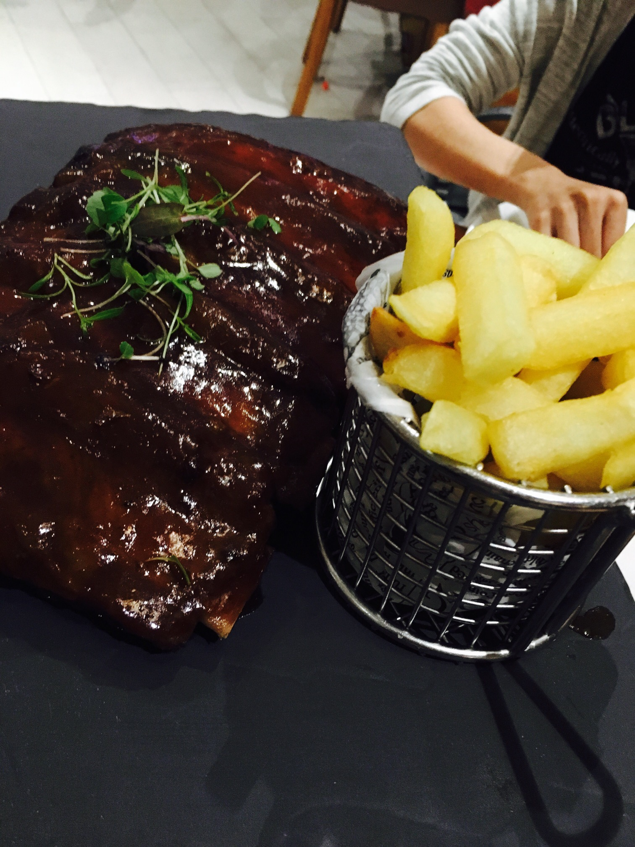

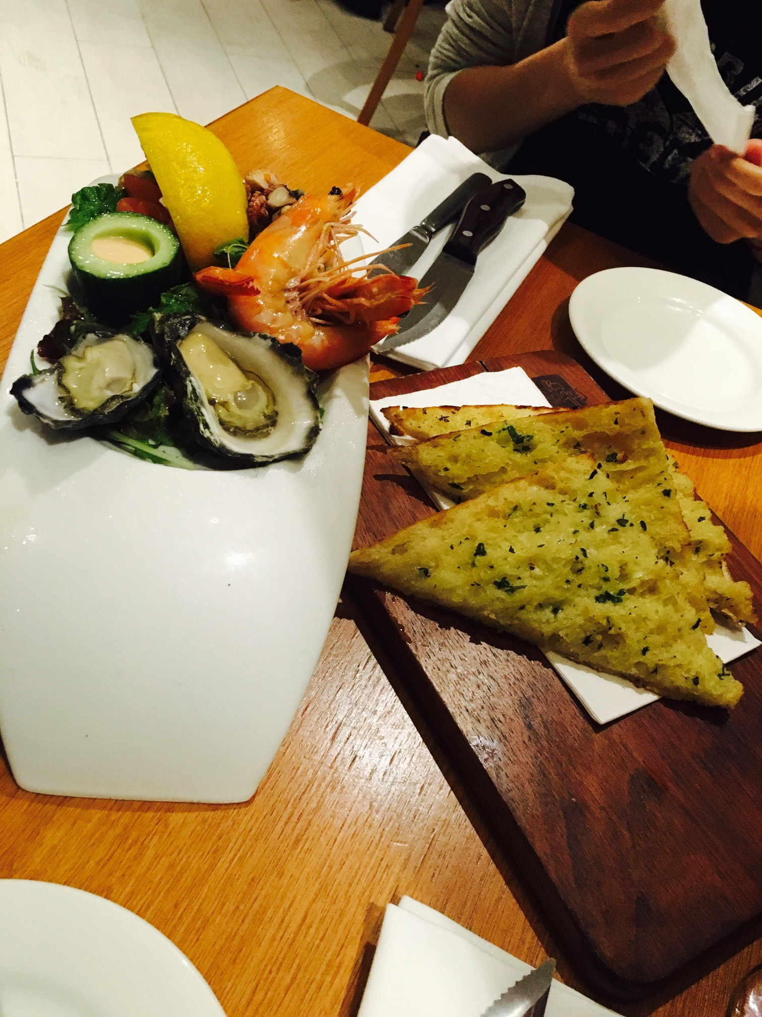

In order to summary the intake of the main food that I ate, firstly I took photo of everything that I ate for these days and make notes for each group. All food that I ate can be divided into 5 group, which includes grain, meat, dairy, fruit and vegetable. Based on website, I have to calculate how many serves that I eat for each group and make a table to record all food that I ate. The process of recording and creating tables is wasting a lot of time, because any apps can help us to do that. All we need is to type in or click on what we ate in the apps. However, in this case, we have to make a note for everything we ate and summaries daily records by ourselves. Therefore, we can use some apps to solve this problems.